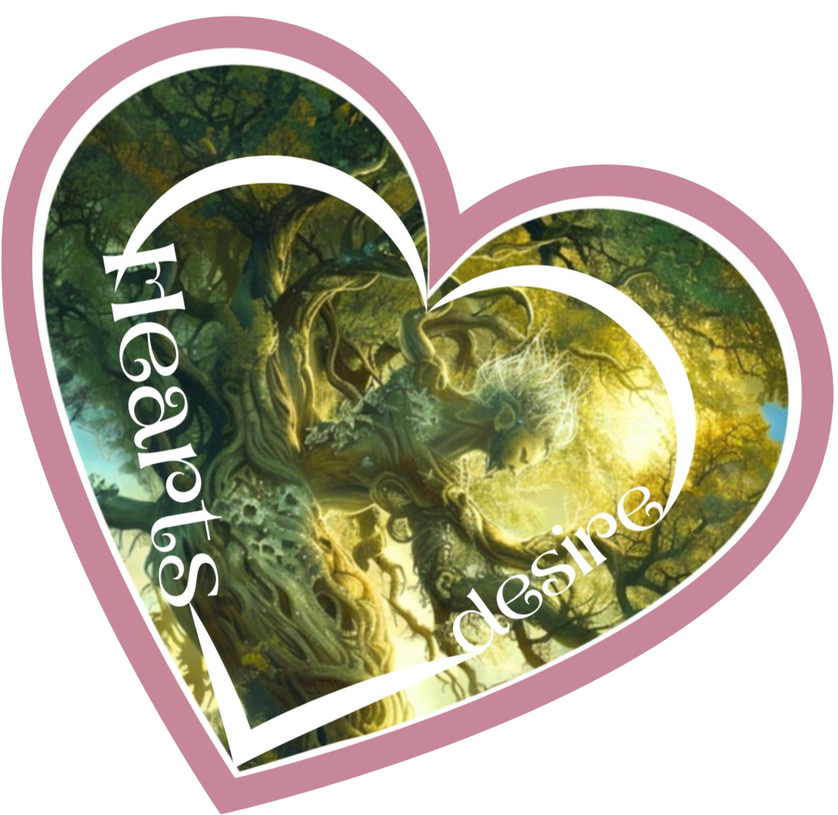We live in a world of struggle, war, inequity, climate threat. The park itself, a shooting range in colonial times, inspires our story. Where can we find our ***Heart’s Desire*** and move forward wth hope?

Theatre creator Eleanor Crowder directs. Metis artist and thinker Suzanne Keeptwo led work on the land acknowledgement which opens the show.

Mask maker Clelia Scala taught the careful process of building masks from the actors’ own face moulds, and designed the puppets.

The company is

Shanelle Roussel Queen Citrine

Zaratamaraun Uduoise General Granite

Ten Schofield Alexandrite

Seren Michaud Prince Pierre

Mel Lucena Rose Quartz

Natasha Knight Willow

Goodness Ade Hawthorne

RJ Mayo Tilius

Andrew Kutikov Nestor

Macy Fuchigami Ivynna & Gnocchi

Isabelle Joubert-Hemish Dahlia & Takoyaki

UE Trần Polly, the pileated woodpecker

Special thanks to RJ Mayo as Directorial Assistant, and to Somin An

Songs and music written for the show by UE Trần and Zara Uduoise

Music Direction by UE Trần

Fight Choreography by Andrew Kutikov and Shanelle Roussel

Writing credits: Macy Fuchigami, Isabelle Joubert-Hemish, RJ Mayo, Seren Michaud, Zaratamaraun Uduoise

Designer Maggie Bee

Production Assistance Diyah Sankalka Harris

Costumes made by Atelier James Lavoie, Kathryn Racine and drawn from the Odyssey Theatre archives.

Our thanks to all the Odyssey Theatre staff and actors for their support of young artists.